

The HL7 Comprehensive Database

User Manual

Author: Frank Oemig

|  |  |
| --- | --- |
| email: | HL7@Oemig.de |
| Current Status: | in progress |
| DB-FIle: | HL7_92.mdb |
| Date: | January 9th 2017 |

Copyright © 2017 by Health Level Seven, Inc.  
ALL RIGHTS RESERVED.   
The reproduction of this material in any form is   
strictly forbidden without the written permission of the publisher.

HL7 makes no warranty of any kind with regard to this database and associated documentation, including but not limited to, the implied warranties or merchantability and fitness for a particular purpose. HL7 shall not be liable for errors contained herein or for incidental or consequential damages in connection with the furnishing, performance, or use of this material. Please read the Database Documentation prior to modifying the database. Keep the medium in a safe place since it is your master copy.

Contents Page

The HL7 Comprehensive Database 1

User Manual 1

1. Installation 4

1.1. Requirements 4

1.2. Constraints 4

1.3. Backup 4

1.4. Warning 4

1.5. List of VB-Modules 4

2. Introduction 6

2.1. Objects used in the HL7 Standard 6

2.2. Structure of a Message 6

3. Getting Started 8

3.1. Selecting Events 9

3.2. Switching to other information 9

3.3. Selecting Segments 9

3.4. Selecting Tables 10

3.5. Selecting Data Elements 11

3.6. Selecting Data Structures 12

3.7. Selecting Message Structures 13

3.8. Selecting Queries 14

3.9. Selecting the Original Chapter Documentation 15

4. Trigger Event Data and Message Structures 17

4.1. Using Consecutive Numbers 19

4.2. Explaining the Relation to Message Types 19

5. Segment Data 21

5.1. Special Segment Codes 21

5.2. Usage of segments 22

6. Table Data 23

6.1. Usage by Data Elements 23

6.2. Usage by Components 24

6.3. Description 25

6.4. Additional information 26

7. Queries 28

8. Standard Chapter Documentation 29

8.1. Chapter Paragraphs 29

9. Data Elements 31

10. Data Type Structures 32

11. Message Types 33

12. HL7 Objects 34

13. Editing Other Information 35

13.1. Options 35

13.2. History 35

13.3. Comments 36

13.4. Further Information 36

14. Adding new information into the database 37

15. Copying Messages 38

15.1. Messages to Messages 38

15.2. Messages to Message Structures 38

15.3. Message Structures to Message Structures 38

15.4. Insert Spaces into Message Structures 39

16. Additional Functions 40

17. Starting Reports 41

18. Generating the HTML-Files 42

18.1. Generation 42

19. Generate Appendix A 44

20. Generate Appendix C 45

21. Generate Documents 46

22. Generate XML Schema 47

23. Generate XML 48

24. Define Documentation 49

25. Help/Troubleshooting 51

Appendix A: Options 52

# Installation

Create a directory on your hard drive for the contents of the CD-ROM and then copy the contents of the CD-ROM to that directory. Once you’ve copied the contents of the CD-ROM to your hard drive, take a moment to ensure that the directory includes database file, a Documents subdirectory, and an HTML subdirectory.

Because the files are delivered on a CD-ROM, they will be “Read Only” when copied to your hard drive. If you wish to update the database at any time, you will need to modify the files you just copied to your hard drive to remove the “Read Only” property. To do this:

1. Use Windows Explorer to select the database on your hard drive.
2. Right click on the mouse. This displays a pop up menu.
3. Choose Properties (the last selection on the pop up menu).
4. Click the Read Only checkbox next to Attributes (under the General tab). The file will be Read Only if a check appears in this checkbox.
5. Follow the procedure above to remove the Read Only property from the HTML files in the HTML folder. Note: You can select all the files in this directory and remove the Read Only property at one time.

Start the user interface by opening the Access database file.

## Requirements

To make use of the complete functionality, **Access2000** including **Visual Basic for Applications** must be installed. If VBA is not available some of the functions will not operate as expected.

## Constraints

This database is defined to use referential integrity wherever it is feasible.

The relation between event message types and messages requires a two-to-many relationship. But this feature is not supported by a relational database. Therefore the referential integrity is defined among events and messages. The rest must be checked by additional queries. (Compare with chapter 5 of the database documentation.)

## Backup

The CD itself is the master copy. If you use this database to maintain additional data, you are responsible for making backup copies regularly.

## Warning

Be aware that the forms directly operate on the tables. Therefore, every change is stored without an additional warning!

## List of VB-Modules

At this place it seems to be a good idea to list all modules needed:

* Visual Basic For Applications
* Microsoft Access 9.0 Object Library
* Microsoft DAO 3.6 Object Library
* Microsoft Word 9.0 Object Library
* OLE Automation
* Microsoft Windows Common Controls 6.0

# Introduction

The general paradigm of HL7 is the exchange of messages that consist of sequences of mandatory or optional segments, fields, components and sub­components. Fields represent the semantic content of the message. In the Standard, the meaning of these segments and the content of fields are explicitly described.

Messages are initiated by trigger events, i.e. real world events that require the transmission of a specific data set.

This comprehensive database contains the HL7 Standard extracted from the Word documents to allow consistency checks of items and to support the application of the Standard by the user.

## Objects used in the HL7 Standard

The following Objects are used within the Standard and are the basis for developing this database:

|  |  |
| --- | --- |
| Event: | The occurrence of an event triggers the assembling and transmission of a message e.g. the admission of a patient is an event. |
| Message: | The message is the smallest object exchange between applications. It consists of a con­catenation of segments, which can be optional or repeatable. |
| Segment: | A segment is an aggregation of data items logically belonging together. Segments can be used in different messages. |
| Data item: | A character string representing the data to be transmitted. |
| Data type: | The data type defines the format of the data item. Atomic and composite data types can be distinguished. Composite data types consist of different components. |
| Component: | A component is part of a data item. |
| Subcomponent: | Components can consist of subcomponents. |
| Table: | Some data items or components require the use of special values that are defined by standard or user defined tables. |
| Query: | A set of information specifying a query. |

## Structure of a Message

In principle, the objects used for defining the Standard are arranged into a hierarchy:



But when analyzing the background and implicit information structure, it results in the following:

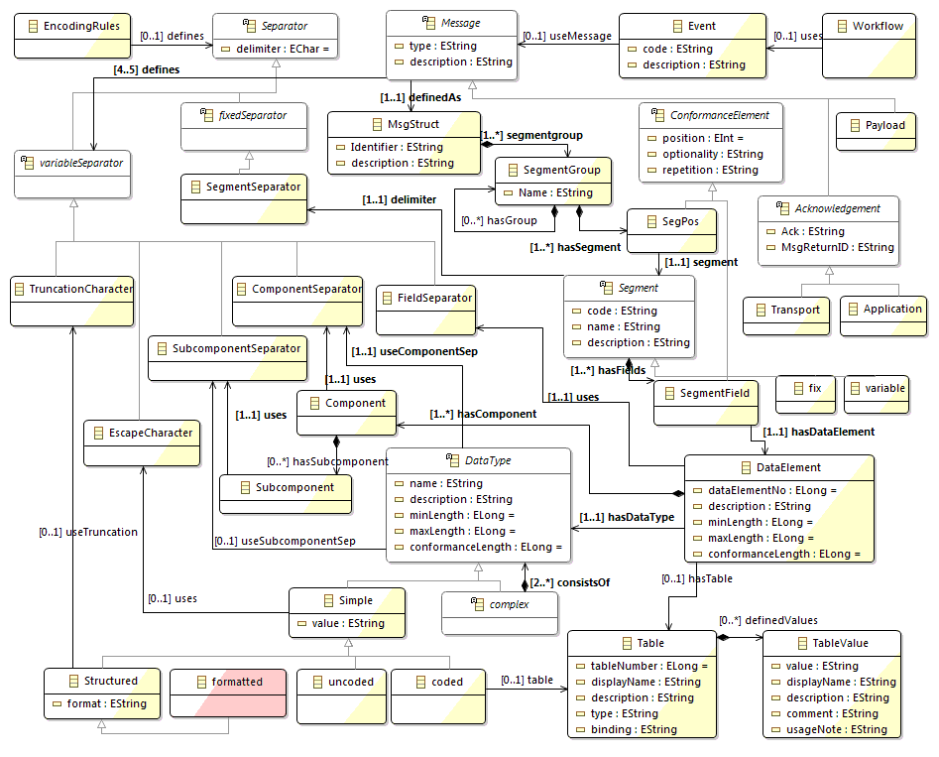

# Getting Started

To start the user interface, simply open the database. The Main Form will open automatically.

Top level combo box for selecting the version.

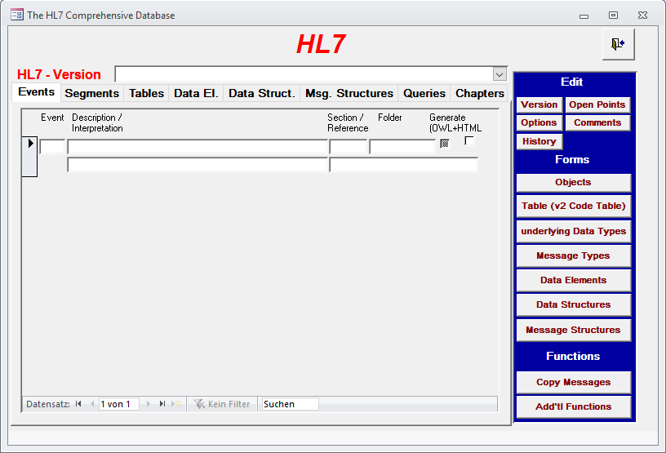

From the top-level combo box, select one version of Standard to work with. (Depending on the module you have purchased more than one version may be available).

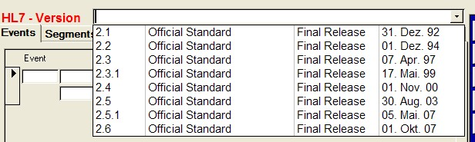

Once you select a version, the list will fill automatically primarily showing a list of events.

## Selecting Events

The Main Form allows you to search for and view Trigger Event information by double-clicking in the row of the list of the Main Form as indicated by the big curly bracket in the graphic below.

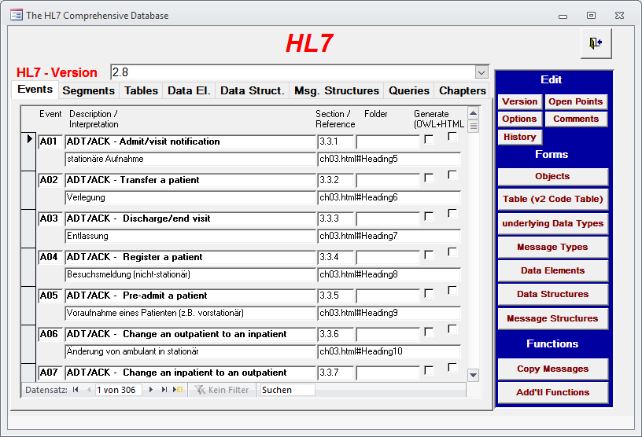

## Switching to other information

Information on segments, tables and conformance statements can be accessed by the same Main Form except the fact they are lying on another folder:

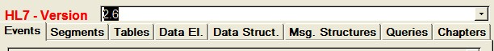

Other folders can be activated by clicking on top of them as indicated by the red arrow above. The resulting folders are listed next.

## Selecting Segments

Segment information is viewed by double-clicking on the left side of the Main Form as indicated by the lower curly brackets in the graphic below.

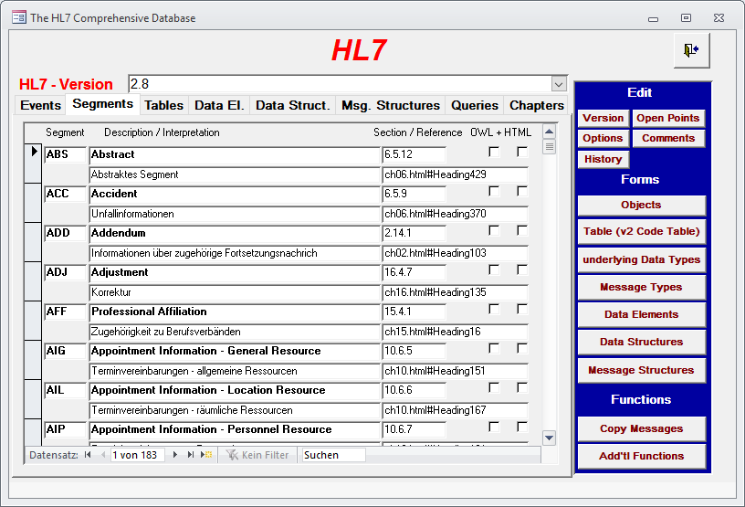

## Selecting Tables

Table information is viewed by double-clicking on the left side of the Main Form as indicated by the lower curly brackets in the graphic below.

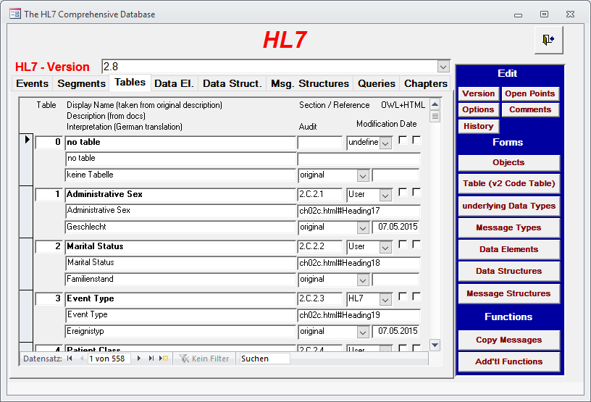

## Selecting Data Elements

Data Element information is viewed by double-clicking on the left side of the Main Form as indicated by the lower curly brackets in the graphic below.

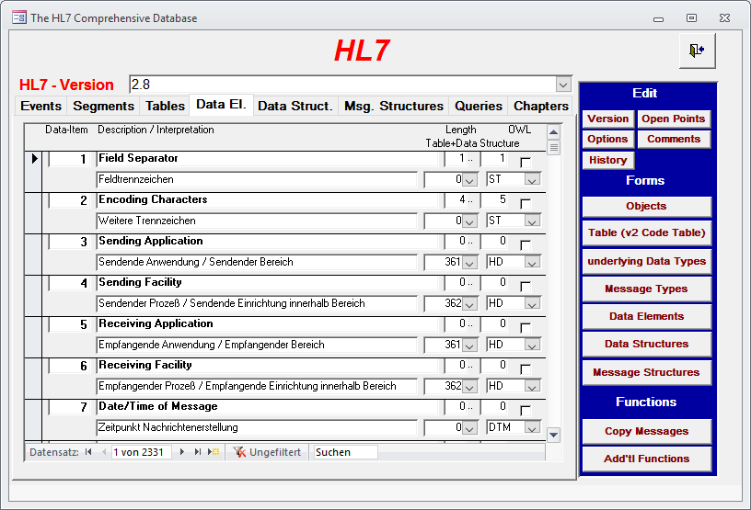

## Selecting Data Structures

The Data structures is viewed by double-clicking on the left side of the Main Form as indicated by the lower curly brackets in the graphic below.

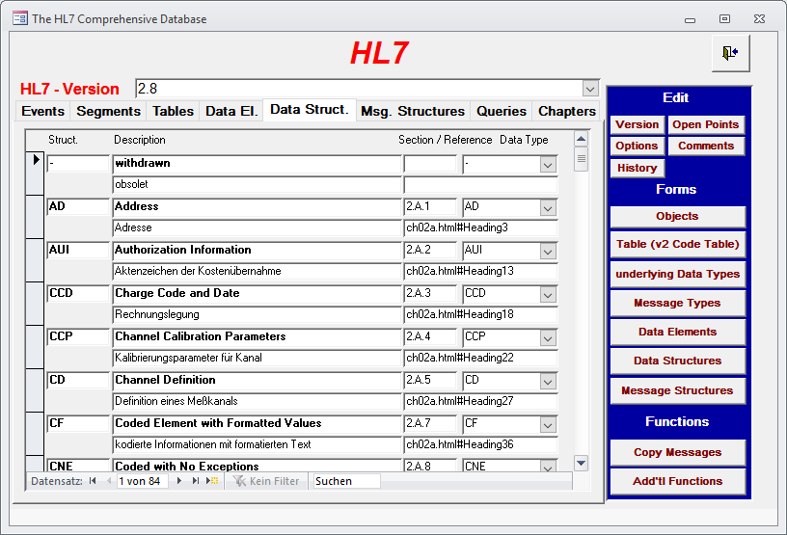

## Selecting Message Structures

The Message structures can be viewed by double-clicking on the left side of the Main Form as indicated by the lower curly brackets in the graphic below.

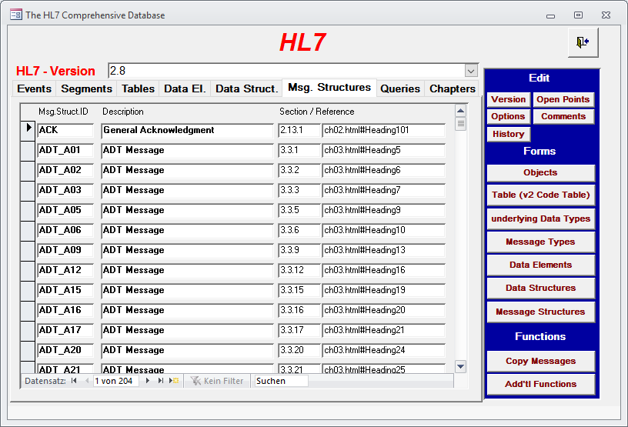

Note: The message structures are identified by providing its ID in the header of the appropriate table. Unfortunately, they are not maintained separately which results in duplication – they are redefined whenever needed – and are not accompanied by a description. Therefore, the field in the database is empty.

## Selecting Queries

The introduced Conformance Statements for Queries can be also viewed by double-clicking in the row:

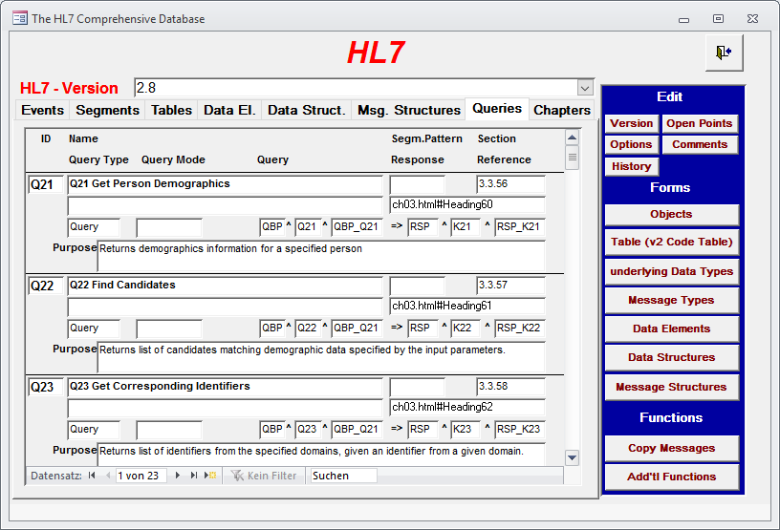

## Selecting the Original Chapter Documentation

With this release of the database a new mechanism has been introduced. It allows for viewing the original documentation order by chapters by double-clicking in the row:

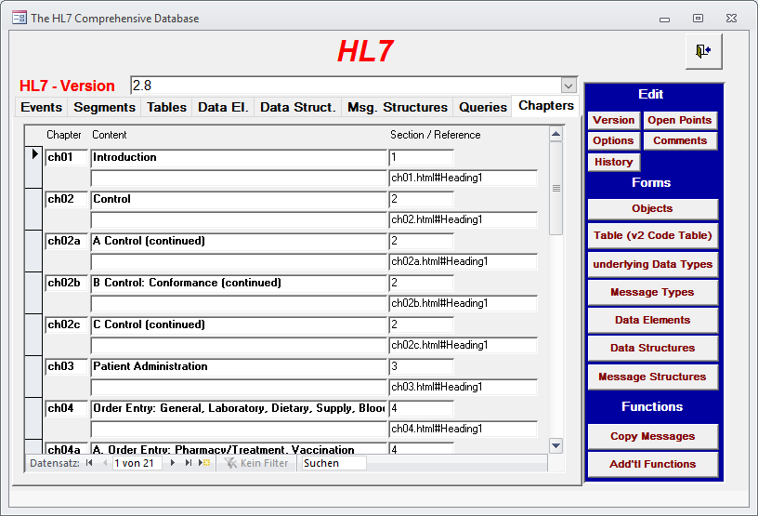

To search for and view information on Data Elements, Data Type Structures, and Message Structures, click on the appropriate push button located in the rectangle with the blue background on the right-hand side of the screen.

All of these actions will display a secondary form that allows you to search for, view, edit and add information. Most of the secondary forms contain navigation buttons in the upper right-hand corner. Use the forward and back arrow buttons to move forward and backward through the records. The Binocular button allows you to search for information. The button on the far right side closes the secondary form and re-displays the Main Form.

All database functions and reports are explained on the following pages.

# Trigger Event Data and Message Structures

To search, view, edit or add trigger event data, display the Main Form. Place your cursor next to the trigger event (on the left side of the form) whose information you wish to view or edit, and then double-click. This displays the Event-Messages Form shown below.

Use the Events-Messages form to view and edit the messages that are exchanged by the sending and receiving applications for the selected trigger event, and to view/edit the message structures themselves (segments and their optionality/repetition).

The middle curly bracket on the graphic below specifies the area where control information is entered for this message. The information about a message itself can be found in the area indicated by the lower curly bracket.

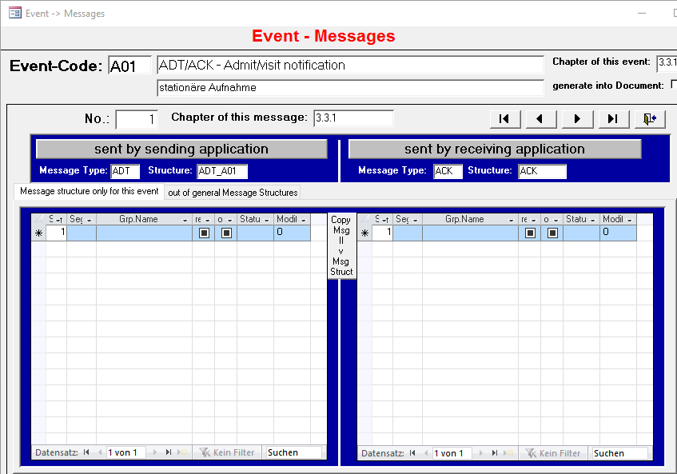

The arrow on the left side of the screen shot points to two folders, one containing the message (structures) that are assigned to the event directly and the other containing the message structures referred to by the message structure identifier. For more information on this detail please see the database documentation.

The next screen shot represents the same message structure (the “ACK” message), but here it is referenced by the message structure identifier.

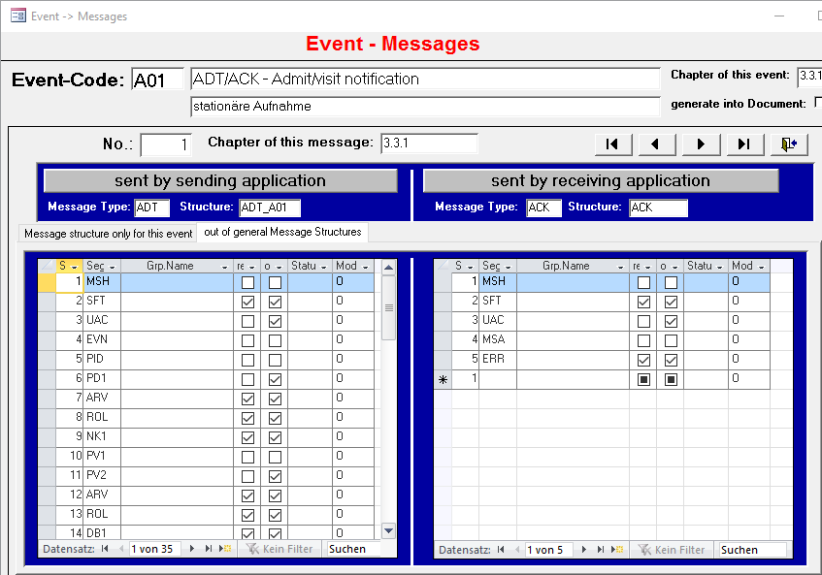

This example explains the two different means of specifying a message structure. In some cases only one segment is optional and/or repeating. This is indicating by use of the corresponding checkbox in one of the right columns, as indicated by a left arrow within the previous screen shot. You can also identify optionality and repetition by adding the opening and closing bracket explicitly. This means must be used to enclose more than just one segment. An example for it is the message for the sending application.

However, the screen shot above is too short to get an impression how to use the fields optionality and repetition. A short example will clarify this. The following message structure descriptions are equivalent. I will take the ADT message A03 because it is a very short message:

| No | Segment | optional | repetition |  | No | Segment | Optional | repetition |
| --- | --- | --- | --- | --- | --- | --- | --- | --- |
| 1 | MSH |  |  |  | 1 | MSH |  |  |
| 2 | EVN |  |  |  | 2 | EVN |  |  |
| 3 | PID |  |  |  | 3 | PID |  |  |
| 4 | [ |  |  |  |  |  |  |  |
| 5 | PD1 |  |  |  | 4 | PD1 | Yes |  |
| 6 | ] |  |  |  |  |  |  |  |
| 7 | PV1 |  |  |  | 5 | PV1 |  |  |
| 8 | [ |  |  |  |  |  |  |  |
| 9 | PV2 |  |  |  | 6 | PV2 | Yes |  |
| 10 | ] |  |  |  |  |  |  |  |
| 11 | [ |  |  |  |  |  |  |  |
| 12 | { |  |  |  |  |  |  |  |
| 13 | DB1 |  |  |  | 7 | DB1 | Yes | yes |
| 14 | } |  |  |  |  |  |  |  |
| 15 | ] |  |  |  |  |  |  |  |
| 16 | [ |  |  |  |  |  |  |  |
| 17 | { |  |  |  |  |  |  |  |
| 18 | DG1 |  |  |  | 8 | DG1 | yes | Yes |
| 19 | } |  |  |  |  |  |  |  |
| 20 | ] |  |  |  |  |  |  |  |
| 21 | [ |  |  |  |  |  |  |  |
| 22 | DRG |  |  |  | 9 | DRG | yes |  |
| 23 | ] |  |  |  |  |  |  |  |
| 24 | [ |  |  |  | 10 | [ |  |  |
| 25 | { |  |  |  | 11 | { |  |  |
| 26 | PR1 |  |  |  | 12 | PR1 |  |  |
| 27 | [ |  |  |  |  |  |  |  |
| 28 | { |  |  |  |  |  |  |  |
| 29 | ROL |  |  |  | 13 | ROL | yes | Yes |
| 30 | } |  |  |  |  |  |  |  |
| 31 | ] |  |  |  |  |  |  |  |
| 32 | } |  |  |  | 14 | } |  |  |
| 33 | ] |  |  |  | 15 | ] |  |  |
| 34 | [ |  |  |  |  |  |  |  |
| 35 | { |  |  |  |  |  |  |  |
| 36 | OBX |  |  |  | 16 | OBX | yes | yes |
| 37 | } |  |  |  |  |  |  |  |
| 38 | ] |  |  |  |  |  |  |  |

The description like the left one will be generated out of the standard documents. It will take 38 records to specify the complete message. The right one will only need 16 records for a complete description but it must be entered by hand. Furthermore it takes additional code to expand the definition to a complete message structure. This code is included into the database. Therefor generating the HTML files will result in a correct message description.

## Using Consecutive Numbers

**Restriction**: In order to reset the information for printing and/or generating the HTML files the first assigned number must be "1". It does not matter if there are gaps, but the first entry must be number "1".

## Explaining the Relation to Message Types

a) There is no rule defining the relationship between events and messages. Sometimes the event type describes the structure and function of the message. In other cases like Master Files it defines the target file to which the data in the message will be transmitted.

b) The Standard is structured such that an event (e.g., O01 and O02) may correspond to more than one message. On the other hand, HL7 users must specify for each event one message for the sender and one for the recipient as a response.

The database accommodates the first condition by the attribute “lfd_nr“ and the second one for „message_typ_snd“ and „message_typ_return“. The second condition also applies to the two attributes for the message structure (the two columns on the right).

The following table is an extract from the database. The first row defines the attributes of the table.

| Event | seq_no | sent by sending application | Sent by receiving application  (as response) | Message structure (sender) | Message structure (recipient) |
| --- | --- | --- | --- | --- | --- |
| Assigned to: |  | Event | Event | Message structure | Message structure |
| Attribute: |  | Message_typ_snd | Message_typ_return | Message_Structure_snd | Message_structure_return |
| A01 | 1 | ADT | ACK | ADT_A01 | ACK |
| ... |  |  |  |  |  |
| A19 | 1 | QRY | ACK | QRY_A19 | ACK |
| ... |  |  |  |  |  |
| O01 | 1  2  3  4  5  6  7  8  9 | ORM  ORM  ORM  ORM  ORM  RAS  RDE  RDS  RGV | NUL  NUL  NUL  NUL  NUL  NUL  NUL  NUL  NUL | OMN_O01  OMD_O01  OMS_O01  ORM_O01  RDO_O01  RAS_O01  RDE_O01  RDS_O01  RGV_O01 | NUL  NUL  NUL  NUL  NUL  NUL  NUL  NUL  NUL |
| O02 |  |  |  |  |  |
| ... |  |  |  |  |  |
| Q01 | 1 | QRY | DST | QRY_Q01 | DST_Q01 |
| ... |  |  |  |  |  |
| Q05 | 1 | UDM | ACK | UDM_Q05 | ACK |

Note the NUL message structure associated with events O01 and O02 above. While NUL indicates that no message should be sent, the entry itself is necessary in the database to maintain referential integrity.

Normally the third and the fifth as well as the fourth and sixth columns contain corresponding values, as noted on the row for event A01 above. Some events, however, are associated with multiple event-dependent messages. Event O01, for example, corresponds to several “ORM”-messages, each of which is identified by a unique combination of message structure identifiers (e.g., “OMN_O01” or “OMS_O01”). In this instance, a message-dependent event cannot be defined because there is no unique message.

# Segment Data

To view and edit segment data, display the Main Form. Select the Segment folder to open the list of segments. Place your cursor onto the row with the segment (on the left side of the form) whose information you wish to view or edit, and then double-click. This displays the Segment Form shown below

Use the Segment form to view and edit the data elements contained within the selected segment.

The information for the segment itself is defined on the left side of the screen as indicated by the first curly bracket. The lower curly bracket denotes the region that displays the definition of a single data element within the selected segment. This region is horizontally divided by a line into two parts: The upper part of this region (as indicated by dark gray) contains the information for the use of this data element within this segment. The lower part lists the information of the data element itself, i.e. information that is shared with other segments.

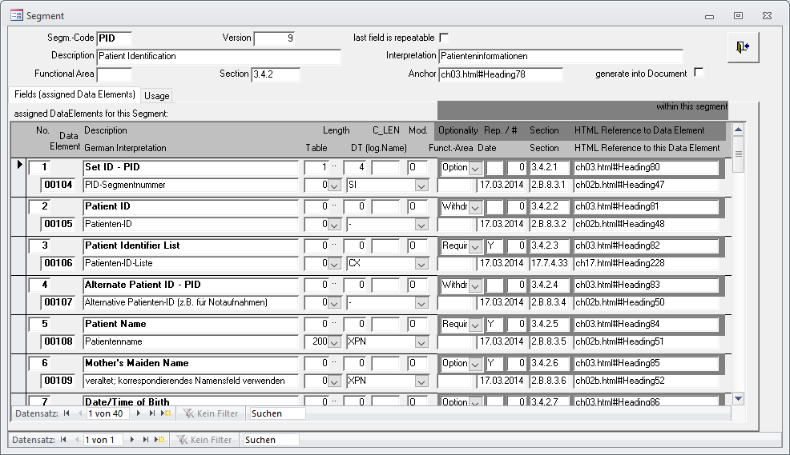

## Special Segment Codes

There has been some special segment codes defined in order to allow the correct description of a message. These segment codes are as follows:

| Special segment code | Purpose |
| --- | --- |
| „[„ | beginning set of optional segments |
| „]“ | ending set of optional segments |
| „{„ | beginning set of repeatable segments |
| „}“ | ending set of repeatable segments |
| „[{„ | beginning set of optional and repeating segments |
| „}]“ | ending set of optional and repeating segments |
| „?“ | any other segment |
| „Hxx“ | any HL7-defined segment |
| “Zxx” | a Z-segment |
| “<” | Begin choice |
| “|” | Next choice |
| “>” | End choice |

These segment codes are also used for indentation.

## Usage of segments

Within the second folder a usage list of this segment can be obtained. Both lists are just for information, therefore they are not editable:

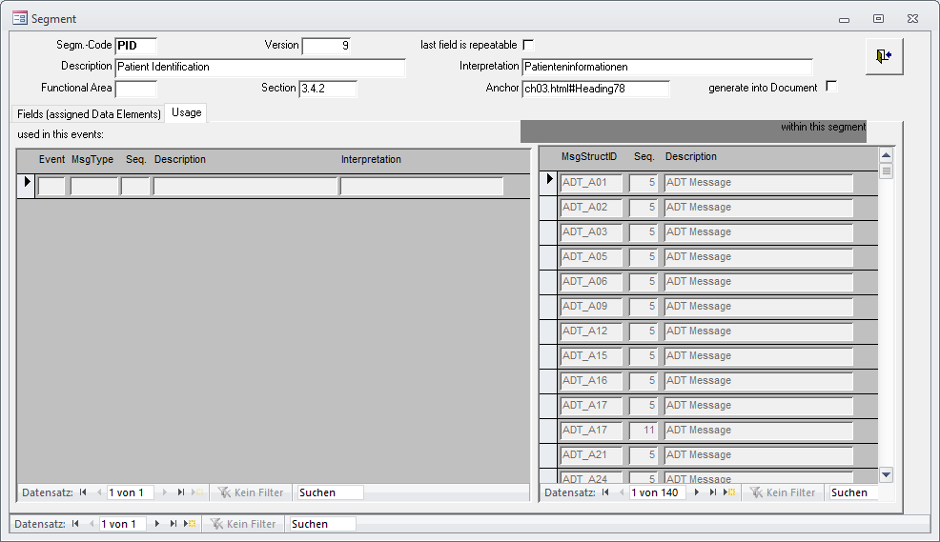

# Table Data

To view and edit table-related data, display the Main Form and select the Table folder. Double-click in the row to display the Table form. This form enables you to view table information.

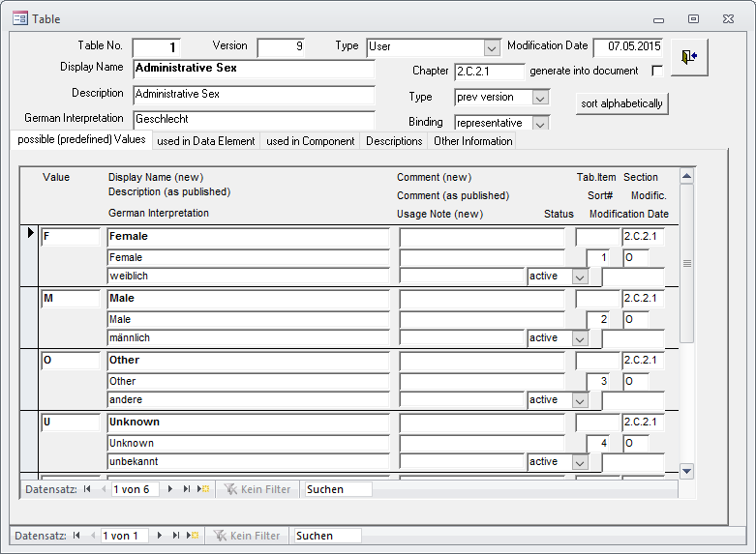

## Usage by Data Elements

The second folder lists the usage of this table by data elements:

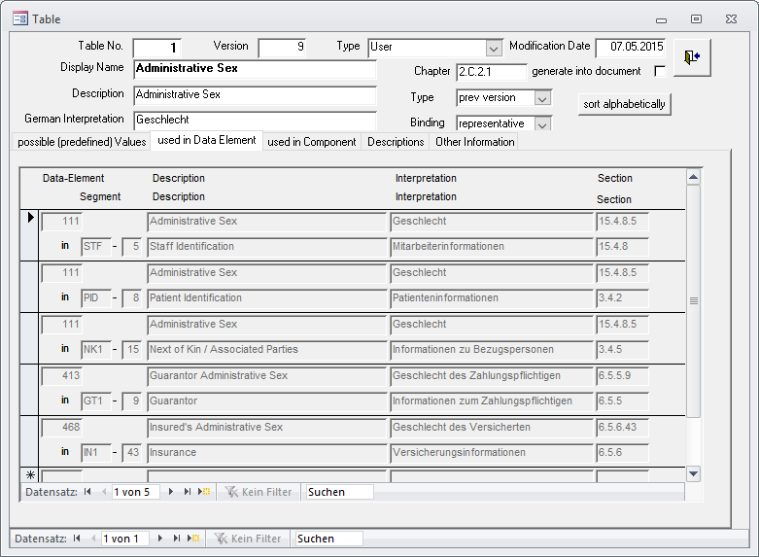

## Usage by Components

The third folder lists the usage of this table by components:

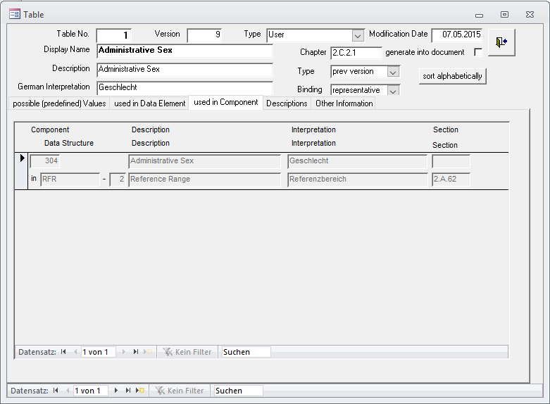

## Description

The fourth folder allows for editing the table description:

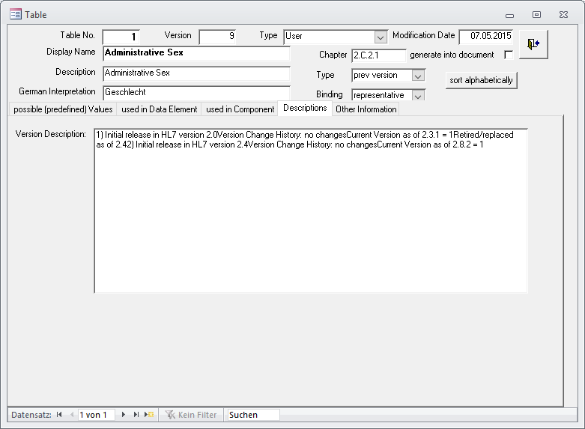

## Additional information

The fifth folder provides fields for editing additional information:

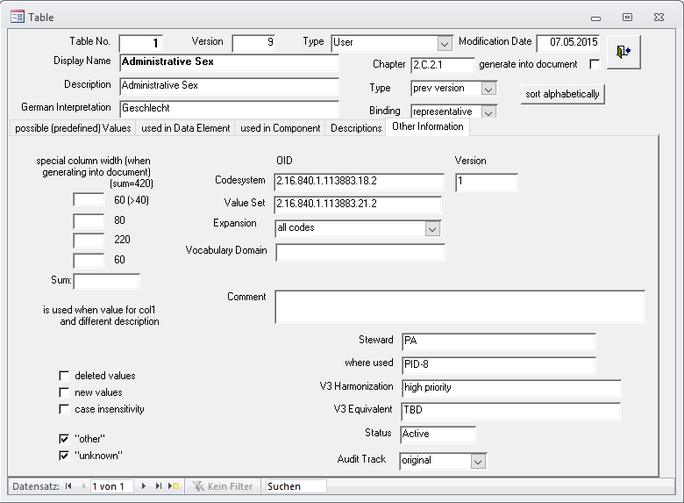

# Queries

Queries are a little bit more complicated. To view and edit the data, display the Main Form and select the Folder Queries. Double-click in the row to display the query form. This form enables you to view and edit query information.

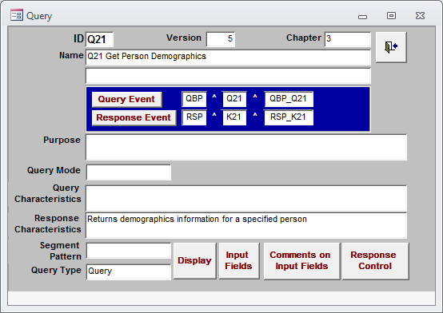

A click to the buttons in the blue field opens the events form which displays the appropriate message.

The four buttons at the bottom opens detailed information about

* display oriented response
* input fields
* and their comments
* response control

# Standard Chapter Documentation

To view (and edit) the original documentation, display the Main Form and select the Chapters folder. Double-click in the row to display the Chapter form. This form enables you to view chapter information.

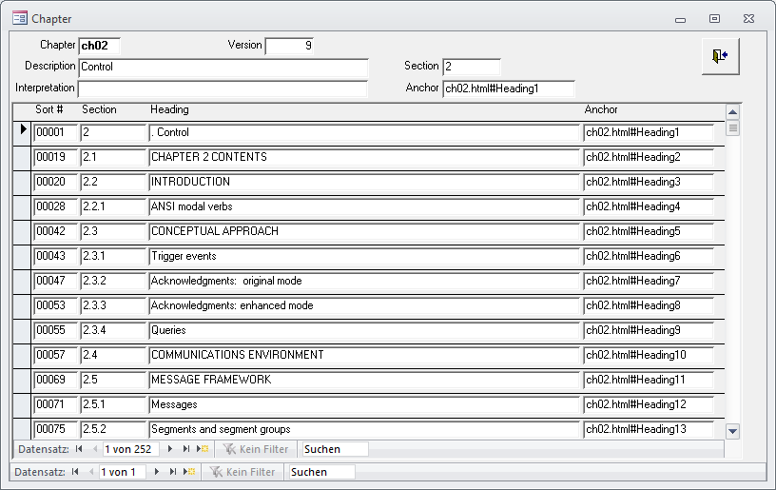

## Chapter Paragraphs

A double click on the section heading opens a from displaying the different paragraphs:

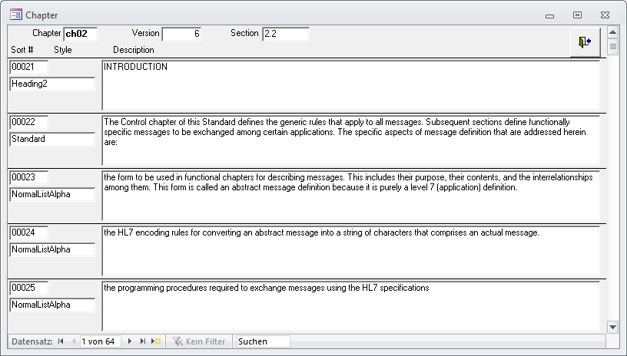

# Data Elements

To view and edit data element data, display the Main Form. Double-click on the Data Elements button (on the right-hand side of the form) to display the Data Elements Form

The Data Element form allows you to search and view information related to a data element: Use the arrow keys to advance to the next data element or reverse to the previous data element. You can also search for a particular data element if you know the element number (Data-Item) or name (Description). To search by element number, place the cursor in the Data Item field, click on the binoculars, then enter the appropriate table number. To search by data element name, place the cursor in the Description field, click on the binoculars, then enter the data element name.

Searching a special data element navigation closing the form

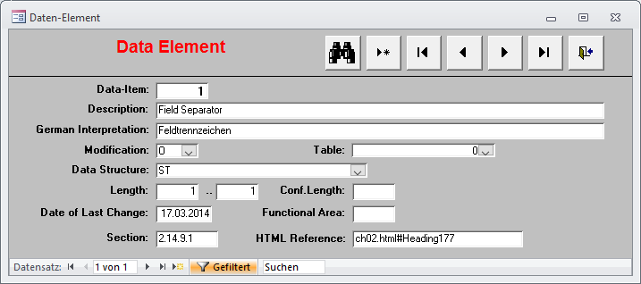

# Data Type Structures

To view and edit data type information, display the Main Form. Double-click on the Data Structures botton (on the right-hand side of the form) to display the Data Structure For Version Form

The Data Structure For Version form allows you to search and view information related to a data types. Use the arrow keys to advance to the next data type and reverse to the previous data element. You can also search for a particular data type if you know its code (Logical Name) or name (Description). To search by data type code, place the cursor in the Logical Name field, click on the binoculars, then enter the appropriate data type. To search by data type name, place the cursor in the Description field, click on the binoculars, then enter the data type name.

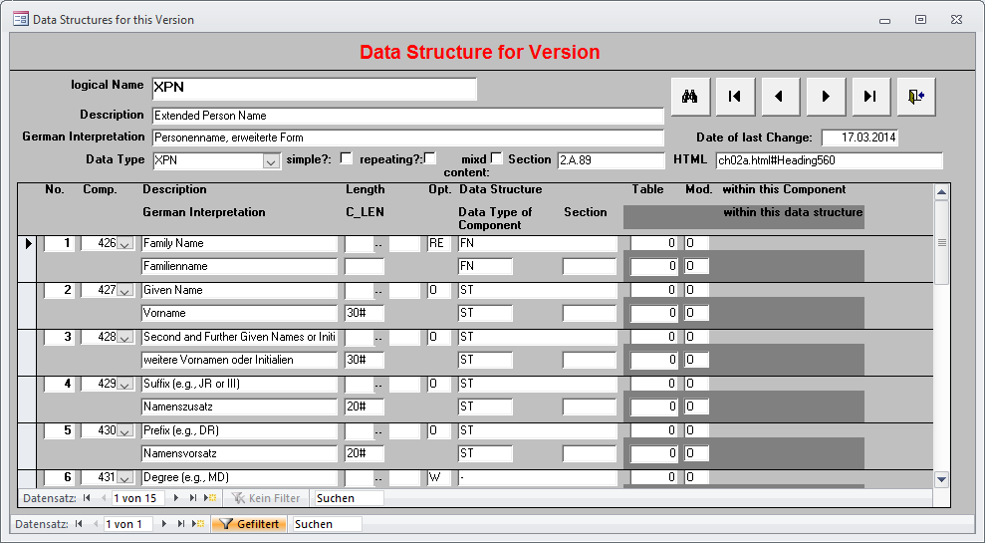

# Message Types

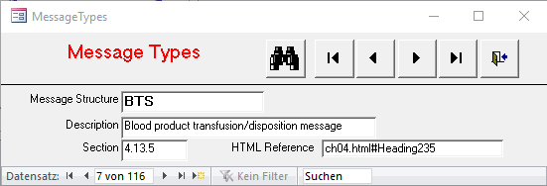

# HL7 Objects

This form supports in editing OID and related information. Beside the description this is the symbolic name.

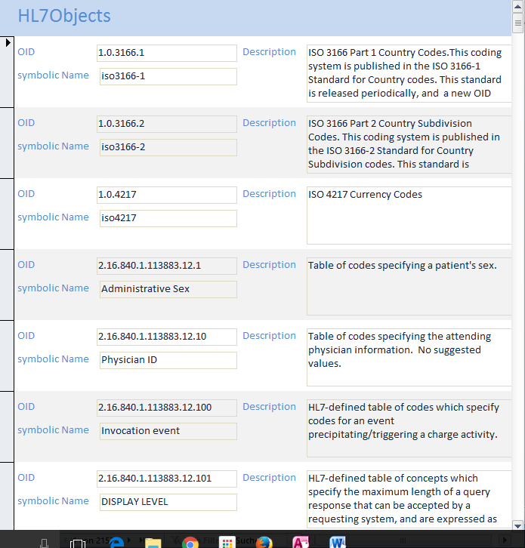

OIDs are used for code systems and value sets.

# Table (v2 Codetable Project)

This form supports in maintaining versioning information for tables. This is achieved by listing all versions for a specific table.

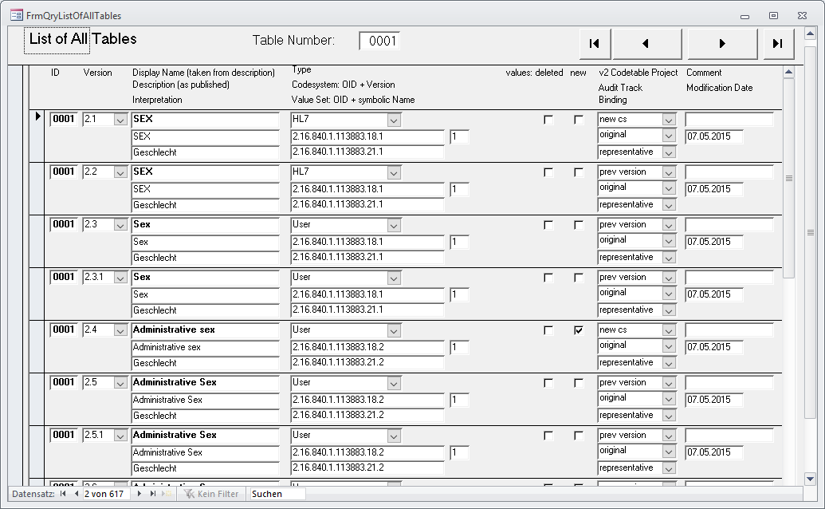

# Editing Other Information

In addition to the forms described above some more information can be edited.

## Options

Options control the behavior of the program. They can be entered by edition of the table directly.

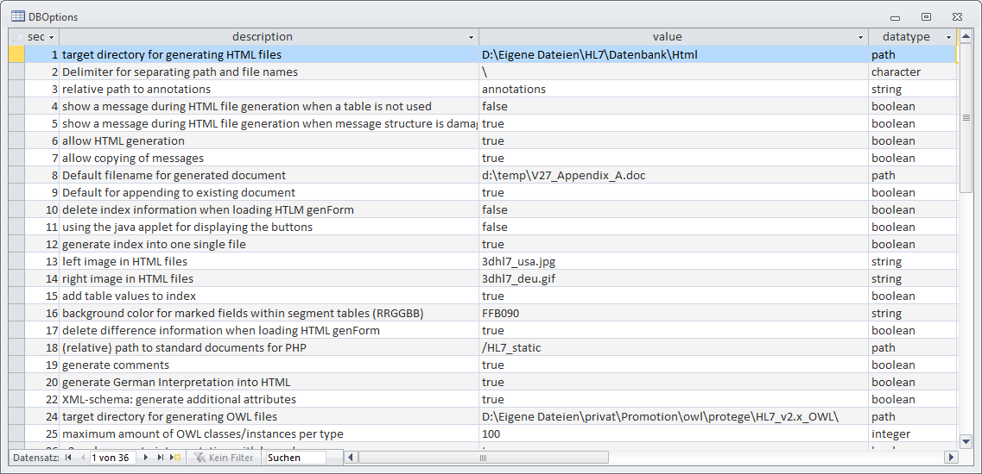

## History

The history globally lists all the changes made to the database.

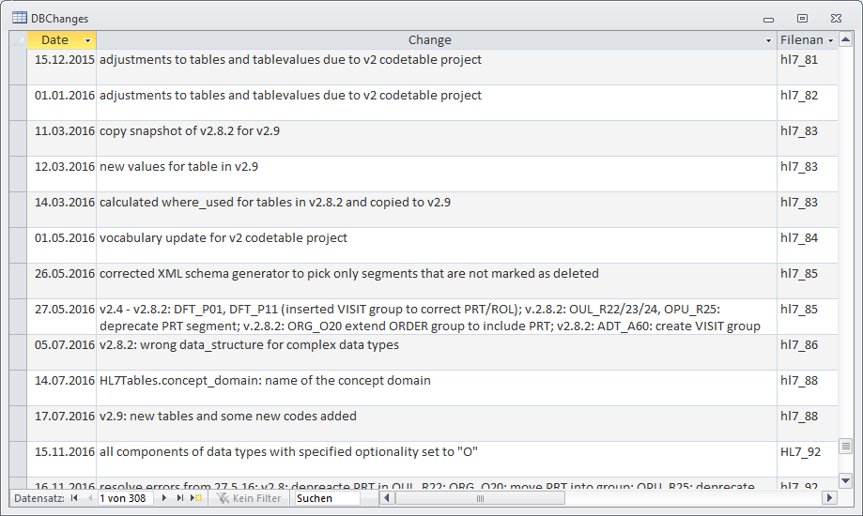

## Comments

Comments can be made on all elements.

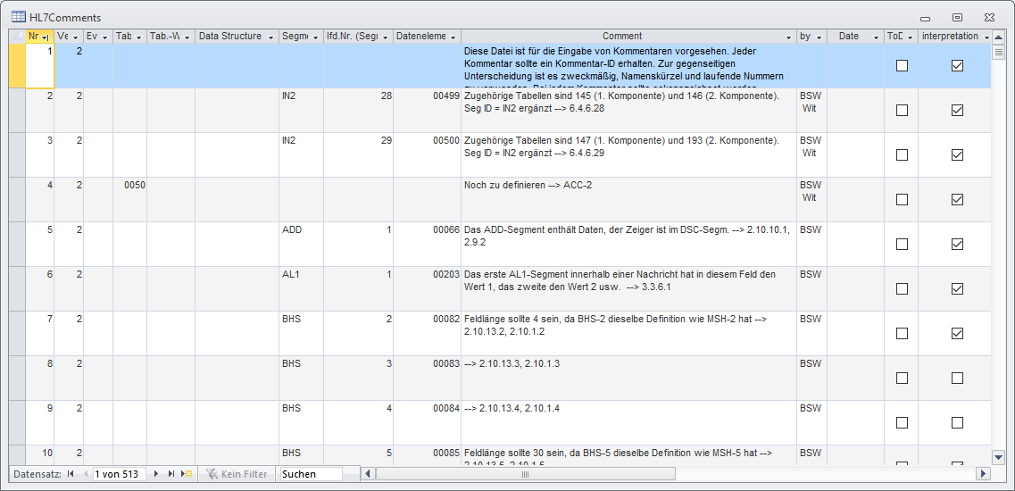

## Further Information

Because the database is not password protected the user can modify the data by editing the tables directly.

# Adding new information into the database

On account of referential integrity it is important to add new information using the correct sequence of steps. I will specify the sequence in form of a list of tables:

1. HL7Versions
2. HL7TableTypes
3. HL7Events
4. HL7Segments
5. HL7Datatypes
6. HL7Datastructures
7. HL7Tables
8. HL7DataElements
9. HL7MsgStructureIDs
10. HL7MessageTypes
11. HL7EventMessagetypes
12. HL7EventMessageTypeSegments
13. HL7MsgStructureIDSegments
14. HL7SegmentDataElements
15. HL7TableValues
16. HL7Components
17. HL7DatastructureComponents
18. HL7Mapping-Table Dataelements
19. HL7Queries
20. HL7QueryInput
21. HL7QueryInputParameter
22. HL7QueryDisplay
23. HL7QueryRCP
24. HL7Chapters
25. HL7ChapterHeadings
26. HL7ChapterParagraphs

# Copying Messages

In order not to define the messages totally by hand three functions are provided to copy the messages which are similar to the desired ones. Therefor only the differences must be edited by hand.

## Messages to Messages

This form copies the messages assigned to one event to another. The currently selected event within the main form provides the source data.

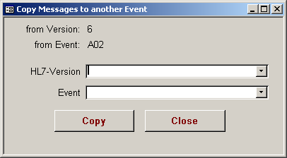

## Messages to Message Structures

This form copies the event depending messages to message structures.

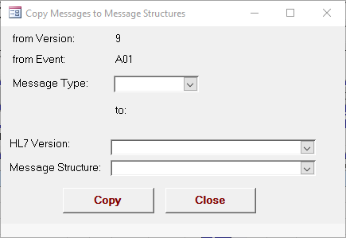

## Message Structures to Message Structures

This form copies one message structure to another.

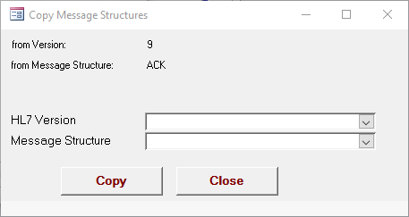

## Insert Spaces into Message Structures

The message structures are stored sequentially, i.e. using an incremental number to specify the order. Inserting new segments into a given structure requires a gap in the numbering scheme. This function inserts a space at a given location.

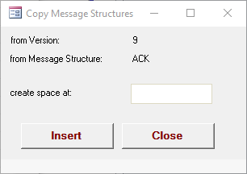

# Additional Functions

With the increase of functionality it is better to provide all the additional functionality by an intermediate menu.

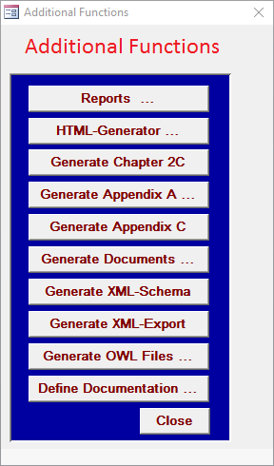

From this point you can open further menus to

* start the generation of reports (chapter 15),
* start the generation of HTML files (chapter 16),
* generate appendix a (chapter 17) or
* generate other information into documents (chapter 18).

# Starting Reports

This form provides buttons to start the reports delivered with this database.

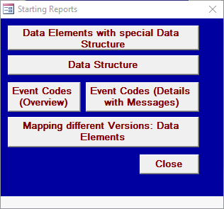

# Generating the HTML-Files

A “starter” set of HTML files is delivered with the database and reside in the HTML subdirectory. The generator allows for generating HTML out of the database, which would most often be done when modifications are made to the database. This set of files builds up network so every view onto the database is covered:



## Generation

Before generating the HTML files, you’ll need to let the database know where to store the HTML files. To do so, go to the Main Form and click the Edit Options button (on the right-hand side of the screen). Enter the path of the HTML subdirectory on your hard drive. To function properly, the generated files need some of the files that are contained in the HTML subdirectory.

**Note:** Ensure that you’ve removed the “Read Only” property from all HTML files in the HTML subdirectory. The database will return a compile error if it attempts to overwrite “Read Only” HTML files in the HTML subdirectory. Refer to Section 1, Installation, for instructions on removing the “Read Only” property from these files. Additionally, the path CANNOT contain any special characters as this, too, will cause the database to return an error message.

Once you’ve indicated where the HTML files are to be stored, click the HTML-Generator button on the Main Window. This displays the Generate HTML Files Form as shown below.

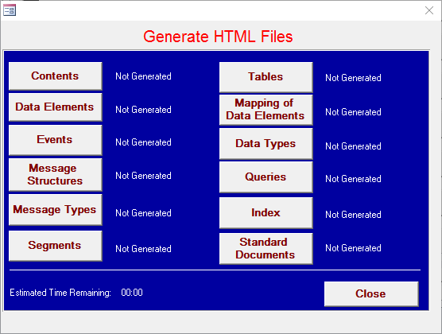

The HTML files must be generated from the top of the list (Contents) to the bottom (Index).

To use the HTML files please open the file

Hl7.html

within you favorite Internet browser. This file can be found in the directory specified by option 1.

Some of the necessary HTML files for the standard are provided separately. They cannot be generated out of the database. Please check the database documentation for details.

# Generate Appendix A

This menu is the entry point to generate a word document into which the information will be inserted.

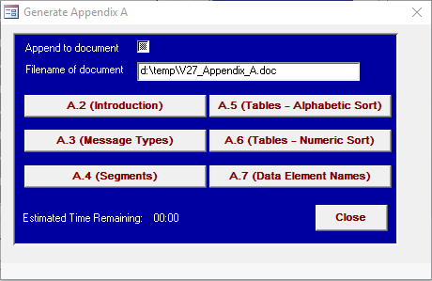

The checkbox indicates whether the information will appended to the end of the document (= checked) or a new document will be created (= unchecked).

The edit field specifies the filename with the path information. The filename where to place the generated information is taken from option 8.

The six bigger buttons below generate one of the subchapter each.

# Generate Appendix C

Appendix C is an eBNF rendering of the contents.

# Generate Documents

This menu allows for generating the information for events, segments and/or tables into Word documents. For all three different kinds of information only those elements are taken which are marked as “generate”. See main folder.

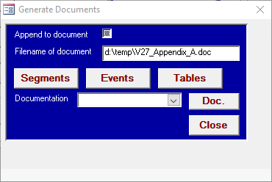

The filename where to place the generated information is taken from option 8.

# Generate XML Schema

This function generates the XML schemas for the selected HL7 version.

The schemas conform to the v2.xml definition.

The target directory is specified in option 21. Option 22 controls whether comments are generated as well. The recommendation is not to generate them due to the size of the messages.

# Generate XML

This function generates a XML file for a specific version.

# Define Documentation

This form is intended to allow for relatively arbitrary documentation. It helps to specify any query to extract data which can in return be used for generation into Word documents. it is based on simple SQL statements. Unfortunately, MS Access does not allow to store big textual information in a field. Therefore, it provides two fields for the main important parts of an SQL string:

* select
* from
* where
* order

These fields are concatenated into the appropriate SQL statement.

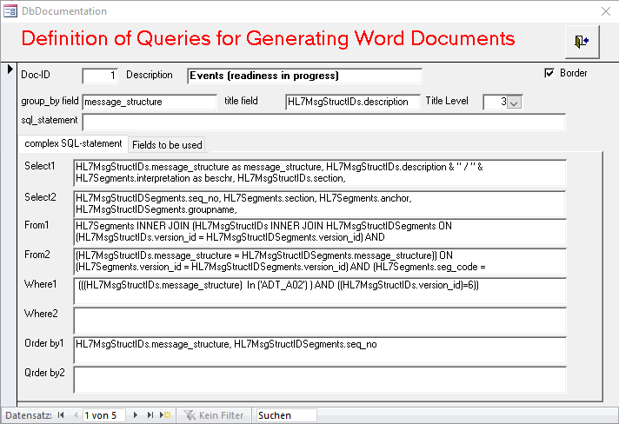

The second part is to be used for the specifying the resulting tables.

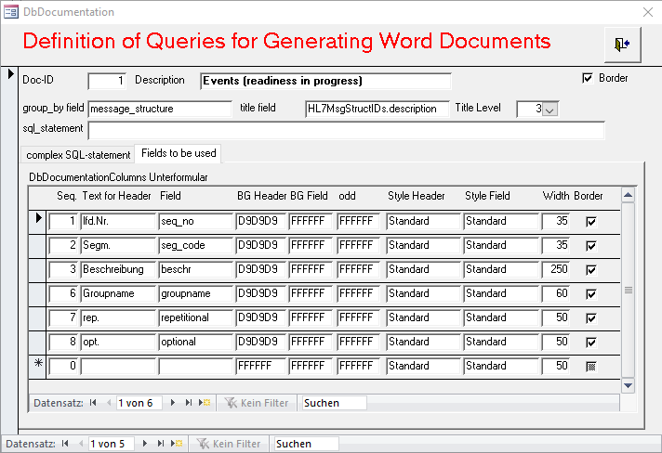

The rest should be self explaining.

These query definitions can be activated generating the documentation.

# Help/Troubleshooting

Should you have problems with the installation process or use of the database, please send e-mail to [HQ@HL7.org](mailto:HQ@HL7.org) and to Frank Oemig, the database creator, at <mailto:HL7@Oemig.de>. The VBA program for generating the HTML files is written to stop at the corresponding statement when an error occurs. Please make a note of this statement in your e-mail message.

# Appendix A: Options

Some of the functions provided allow for user-specific adaptation as noted below:

| No. | Description | Value | Example | Data type | Database |
| --- | --- | --- | --- | --- | --- |
| 1 | Target directory for generating HTML files | Pathname | C:\My Files\.....\database\html | path | HL7_36 |
| 2 | Delimiter for separating path and file names.  (“\” for DOS or “/” for UNIX is re­commen­ded) | Single character | \ | Character | HL7_36 |
| 3 | Relative path to annotations | Relative pathname | annotations | String | HL7_36 |
| 4 | Show a message when a table is not used. This value is evaluated when no reference to a table out of data elements, data structures or components is found during the HTML generation process. | True or false | False | Boolean | HL7_36 |
| 5 | Show a message when message structure is damaged. This value is evaluated during the HTML generation process when a message structure seems to be damaged, i.e. opening and closing brackets do not correspond. | True or false | True | Boolean | HL7_36 |
| 6 | Allow Generation of HTML files. | True or false | True | Boolean | HL7_36 |
| 7 | Allow copying of messages. Three different copy procedures are provided:  Messages ⇒ Messages  Messages ⇒ Message Structures  Message Struct. ⇒ Message Struct.  This option controls whether copying of messages should be permitted or not. This protects against accidental pressing this button. | True or false | True | Boolean | HL7_36 |
| 8 | Default filename for generated document (appendix A or the other one) | Filename (with path) | C:\tmp\test.doc | String | HL7_37 |
| 9 | Default for adding to existing document: when generating the document this option indicates whether to add to the end of the document (true) or to create a new document (false). | True or false | True | Boolean | HL7_37 |
| 10 | delete index information when loading the form for generating the HTML files.  This can be set to false for testing reasons. | True or false | True | Boolean | HL7_37 |
| 11 | Buttons using a java applet instead of distinct files | True or false | True | Boolean | HL7_37 |
| 12 | Generate index into a single file | True or false | False | Boolean | HL7_38 |
| 13 | filename for left image in HTML header | Filename (without path) | hl7_usa.jpg | String | HL7_42 |
| 14 | filename for right image in HTML header | Filename (without path) | hl7_deu.jpg | String | HL7_42 |
| 15 | Add all table values to the index as well | True or false | True | Boolean | HL7_46 |
| 16 | Background color for highlighting changed fields within segment (attribute) tables | RGB color | DD1010 | String | HL7_46 |
| 17 | delete difference information when loading HTLM genForm | true |  | boolean | HL7_53 |
| 18 | relative path to the generated HTML files | pathname (without trailing backslash) | ..\data\html | path | HL7_55 |
| 19 | generate comments | False | false | Boolean | HL7_57 |
| 20 | generate German Interpretation into HTML | False | false | Boolean | HL7_59 |
| 21 | DELETED |  |  |  | HL7_64 |
| 22 | XML-schema: generate additional attributes | False | false | boolean | HL7_59 |
| 23 | unused |  |  |  |  |
| 24 | target directory for generating OWL files |  |  | path |  |
| 25 | maximum amount of OWL classes/instances per type |  | 100 | integer |  |
| 26 | v2.xml: generate interpretation with lang=de |  | true | boolean |  |
| 27 | v2.xml: generate minLength and maxLength |  | true | boolean |  |
| 28 | filename including path for Appendix C |  | d:/temp/Appendix_C.doc | path |  |
| 29 | ask for the target directory when generating the XML schemas in case no dir give |  | true | boolean |  |
| 30 | where to place the generated XML files | pathname (with trailing backslash) | D:\temp\ | path | HL7_71 |
| 31 | root OID for generating codesystem OID for tables |  | 99.99.1.2.3.4 | String | HL7_73 |
| 32 | next extension to OID for generating codesystem OID for tables |  | 1 | integer | HL7_73 |
| 33 | root OID for generating value set OID for tables |  | 99.88.7.6.5.4 | string | HL7_73 |
| 34 | next extension to OID for generating value set OID for tables |  | 1 | integer | HL7_73 |
| 35 | which information (table column) to use to display the text of table values |  | display_name | string | HL7_84 |
| 36 | which information (table column) to use to display the comment on table values |  | Comment | String | HL7_84 |
| 37 | where to generate the refactored HTML files |  | d:\temp\refactored\ | Path | HL7_90 |
| 38 | where to generate other documents |  | d:\temp\ | Path | HL7_90 |